GAME MENU

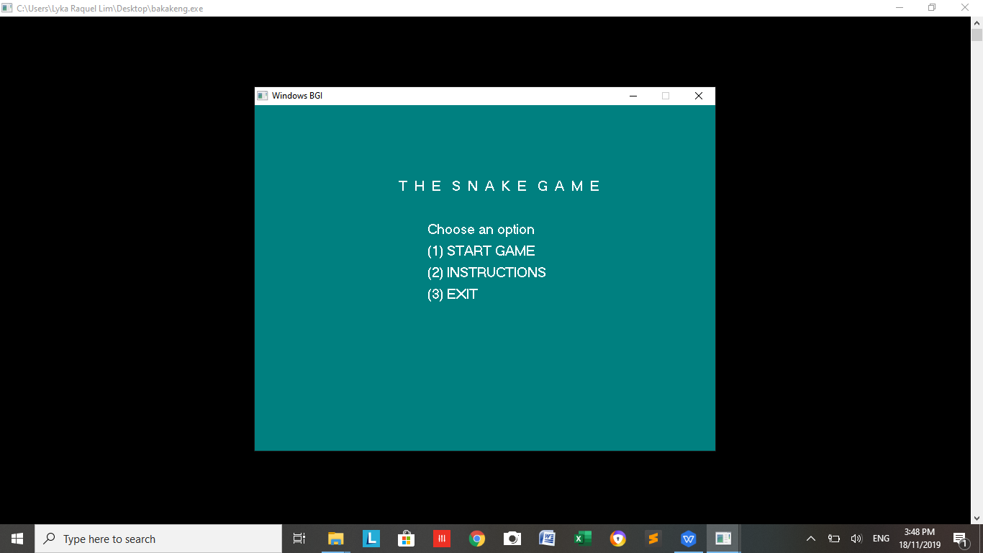

1. (1ST CASE) START GAME - EASY - ENTER 15 - 15 FOODS WILL APPEAR - PORTAL WILL APPEAR - WINS THE GAME -

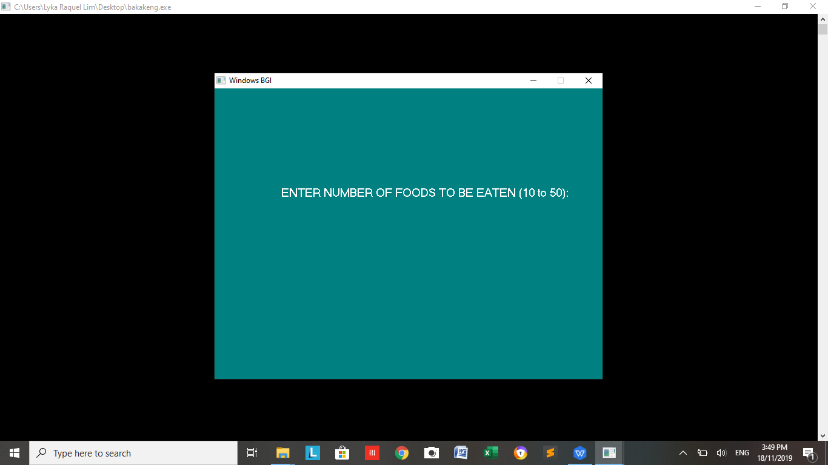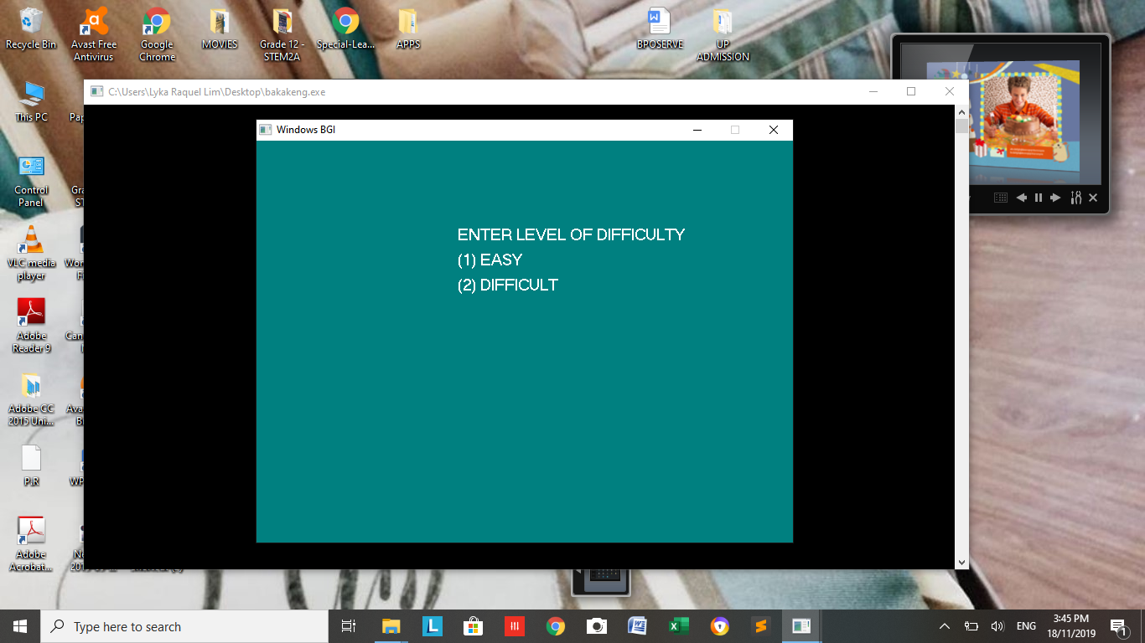

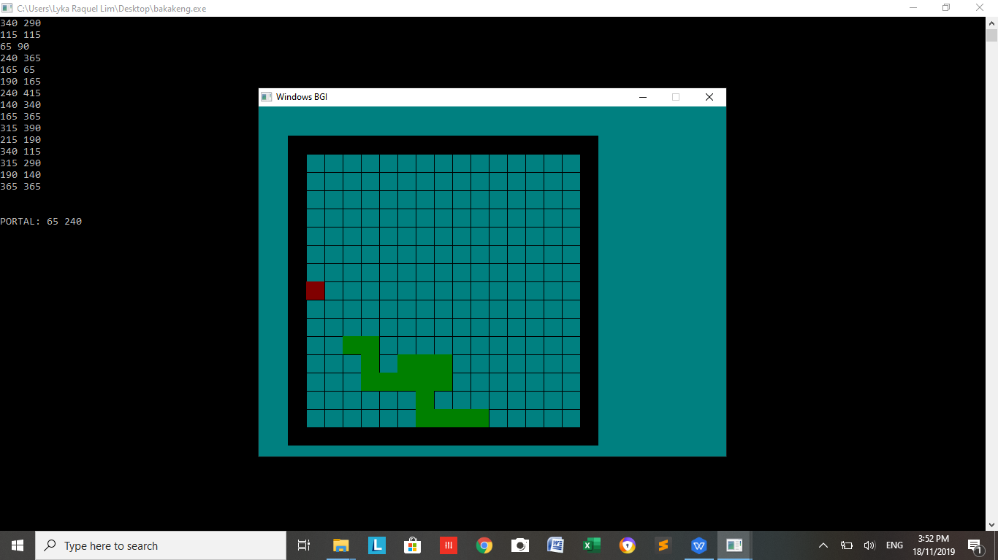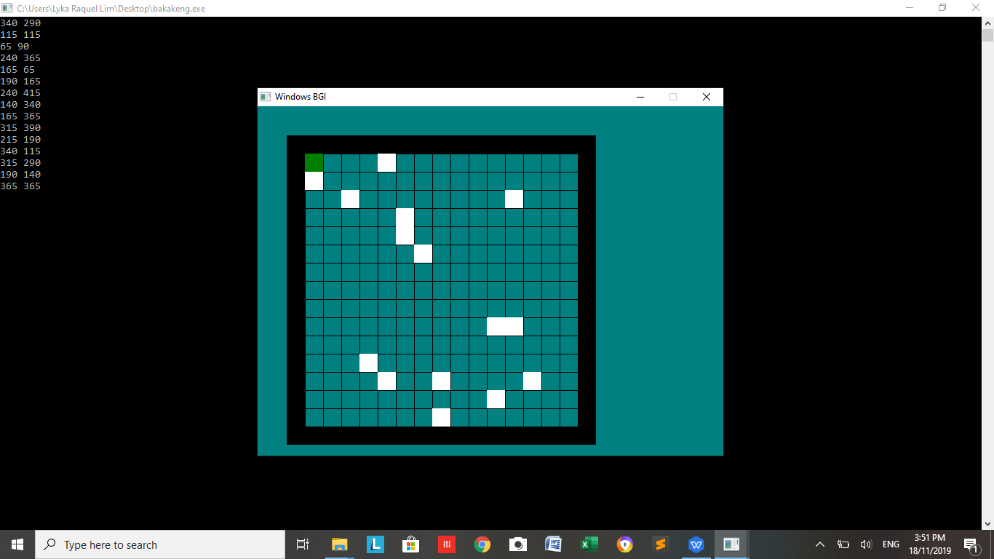

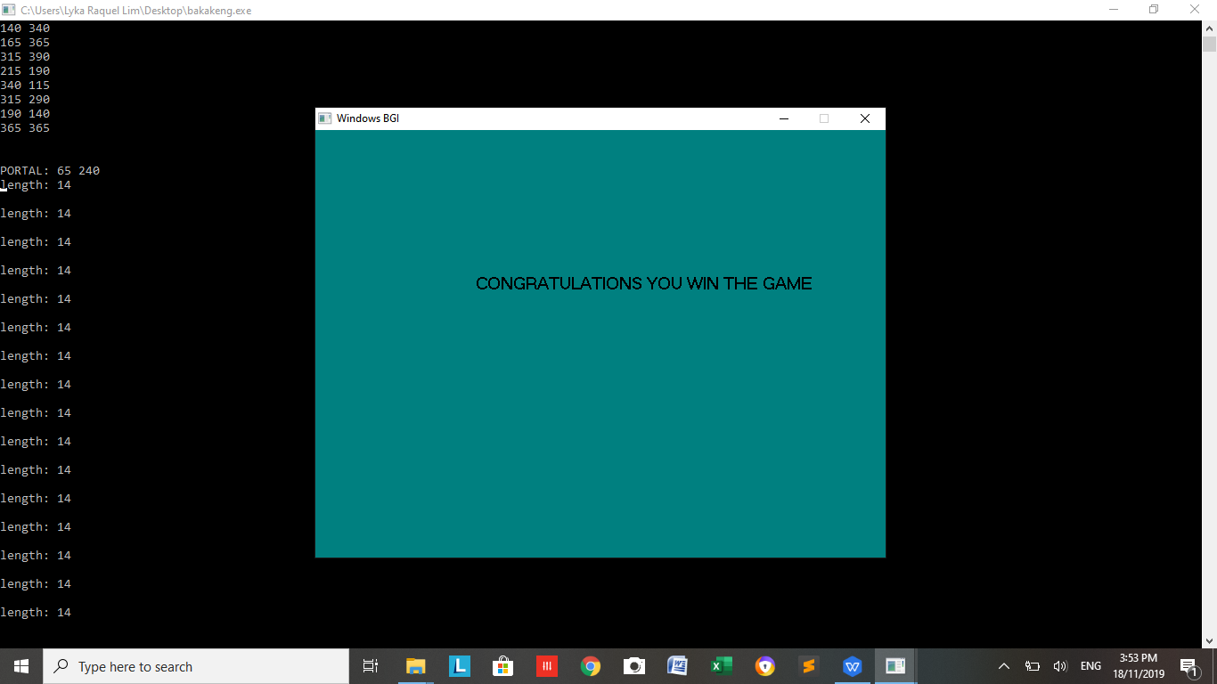

1. (2ND CASE) START GAME - DIFFICULT - ENTER 15 FOODS - 15 FOODS AND 10 BLOCKS WILL APPEAR - PORTAL WILL APPEAR - WINS THE GAME

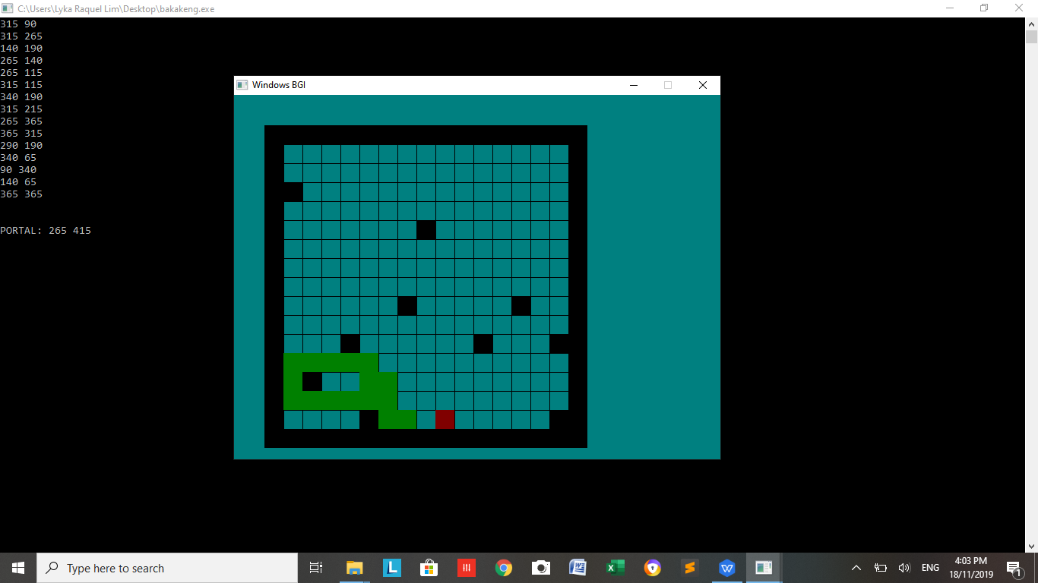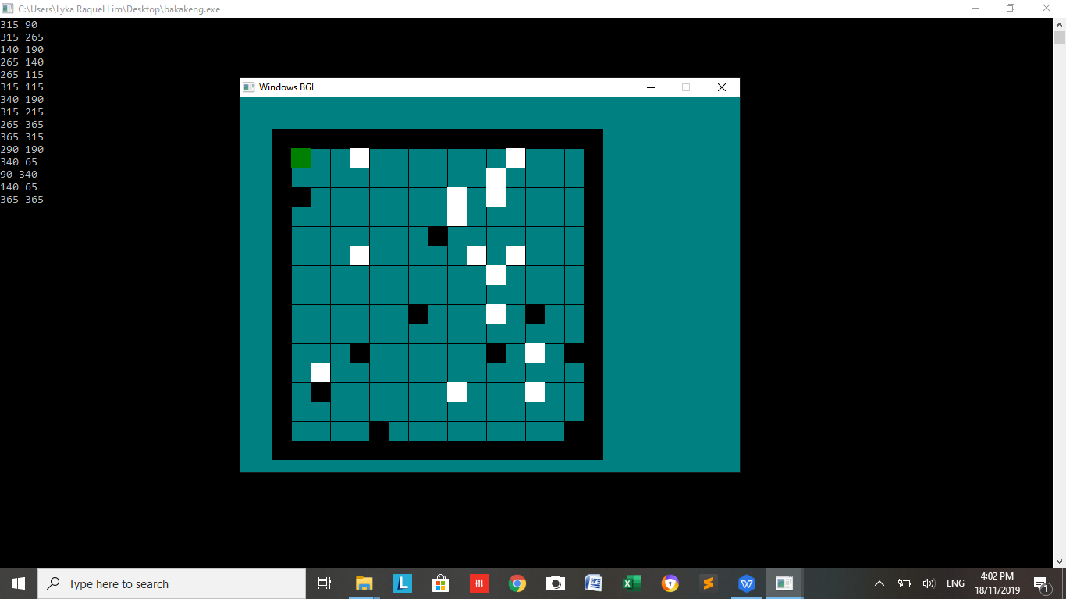



1. INSTRUCTIONS

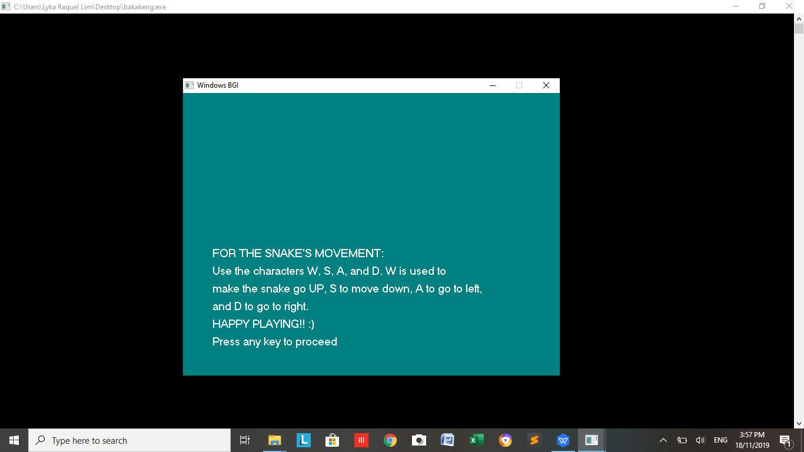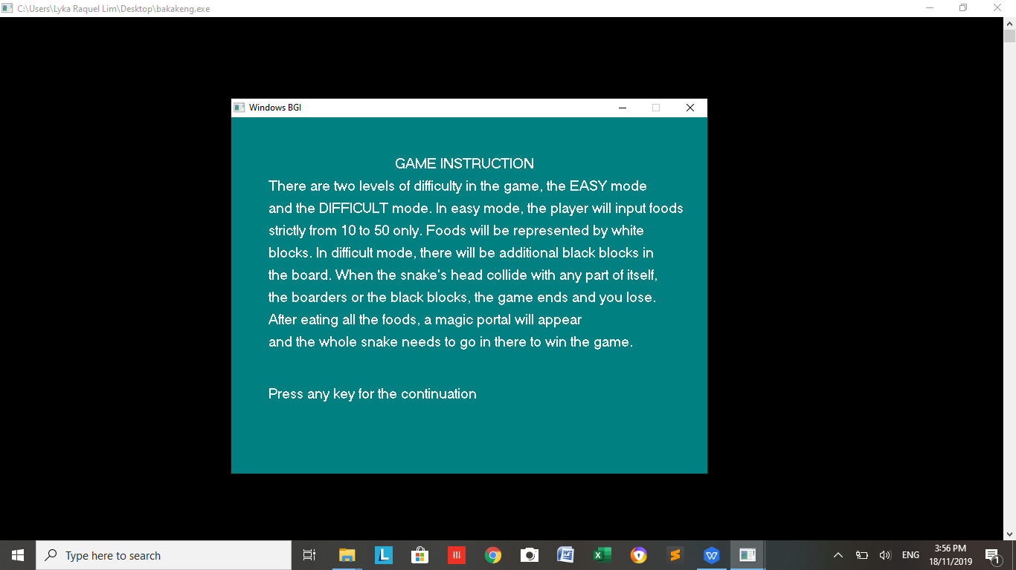

1. EXIT

- THE PROGRAM WILL TERMINATE

SPECIAL CASES:

1. IF INPUT IS NOT IN THE OPTION

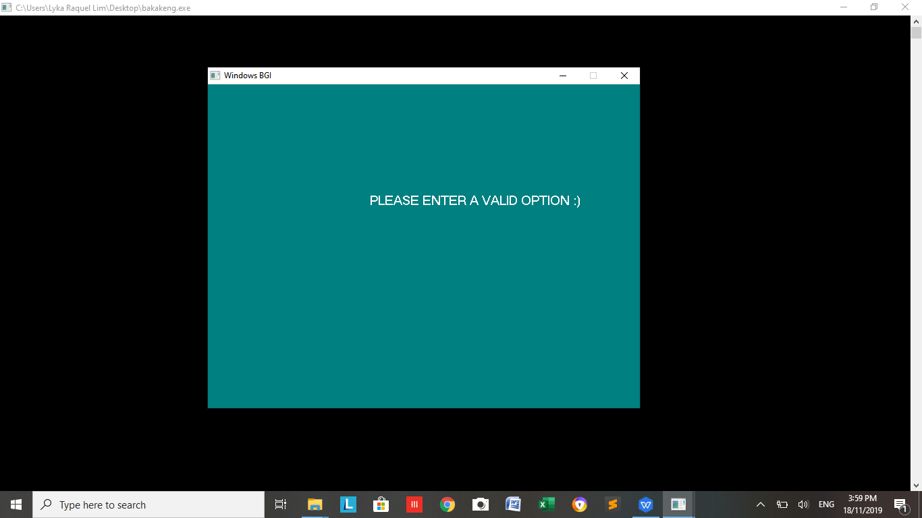

1. IF SNAKE’S HEAD COLLIDES WITH ITS BODY

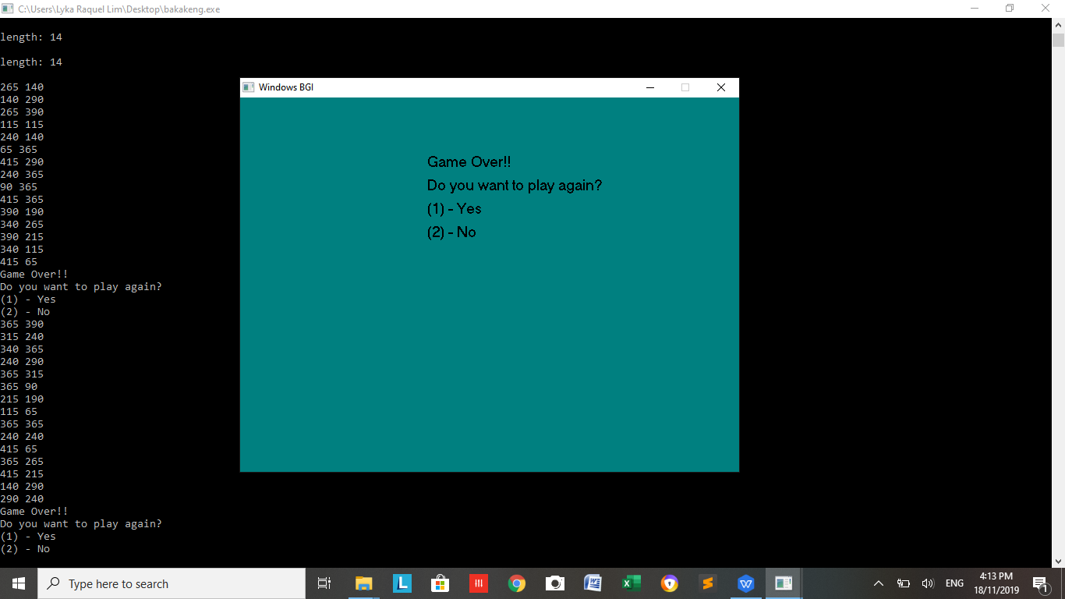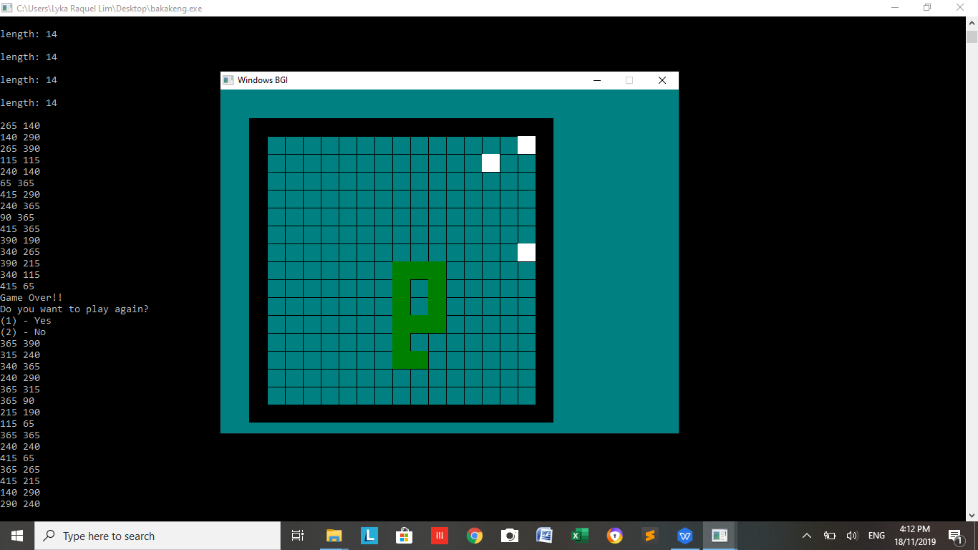

(C ) IF SNAKE’S HEAD HITS A BLACK BLOCK

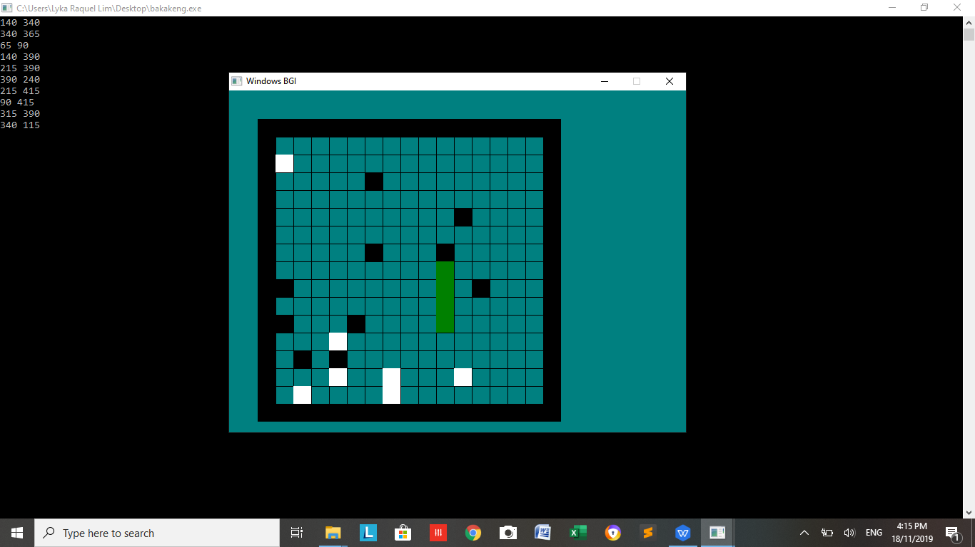

( D) IF SNAKE’S HEAD HITS A BOARDER



